Type your full name 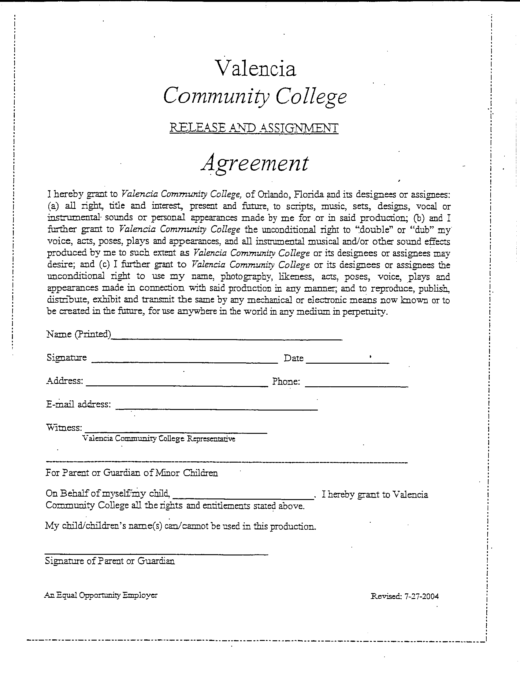
Please read and sign the media release form for online classes and proctoring purposes
Name: Date: .

